**Modeling for the watering system**

**Introduction**

This note introduces how to learn a watering system MTheory using a relational data.

Index

1. Installing the HML JAVA project 1

2. Importing a water system relational data into MySQL 2

3. Executing HML-UnBBayes 2

4. Learning the WateringSystem MTheory 3

5. Reasoning the WateringSystem MTheory 11

[References] 14

## Installing the HML JAVA project

To install the HML JAVA project, two JAVA projects MEBN and UnBBayes are initially required. After installing MEBN and UnBBayes, use the following link to install the HML JAVA project.

<https://github.com/HML-UnBBayes/hml.git>

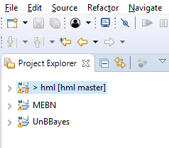

If successfully these are installed, we can see three projects as shown in the above figure.

## Importing a water system relational data into MySQL

The HML JAVA project includes a water system relational data.

By using “watering_system.sql” in the red box, we can create the water system relational data in MySQL.

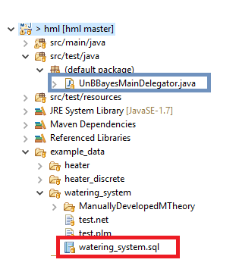

## Executing HML-UnBBayes

To execute HML-UnBBayes, use the “UnBBayesMainDelegator.java” file in the blue box in the above figure.

## Learning the WateringSystem MTheory

To learn the WateringSystem MTheory, click the button “H” in HML-UnBBayes.



Insert the username and password for your MySQL.

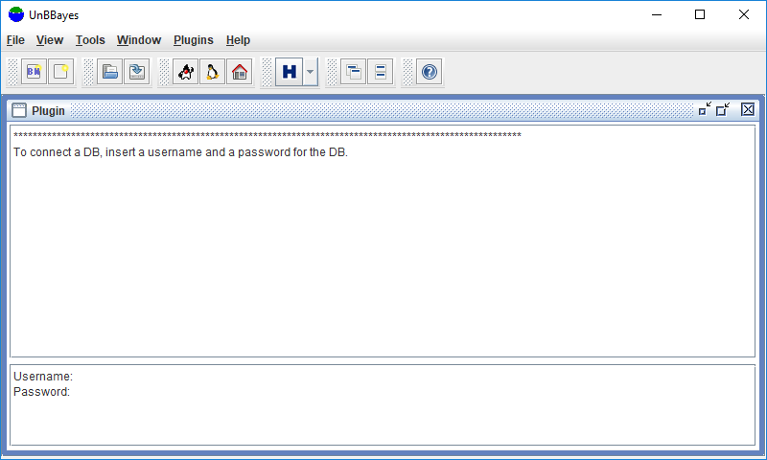

Select the database “wateringsystem”.

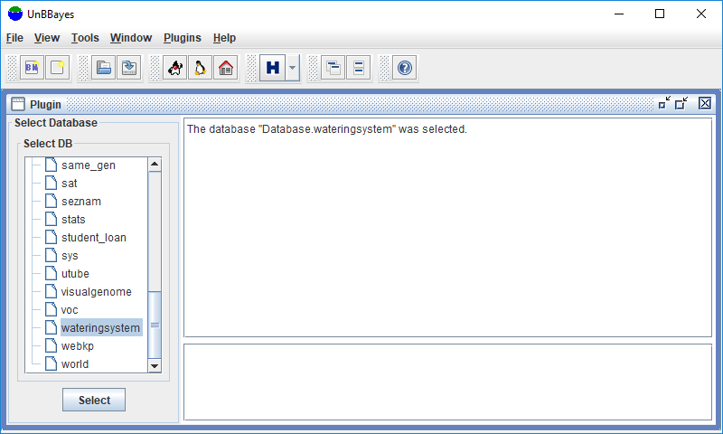

Click the button “Next[Add Parents]>>”.

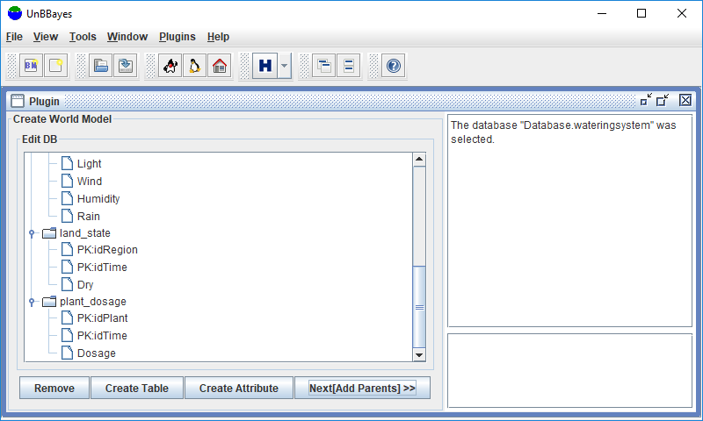

Click the item “land_state_Dry” in the tree view Child RVs.

Also, click the following items in the tree view Parent RVs.

* plant_PlantType
* region_LocationType
* time_Season
* time_DayTime
* environmental_factors_Temperature
* environmental_factors_Light
* environmental_factors_Wind
* environmental_factors_Humidity
* environmental_factors_Rain
* plant_dosage_Dosage

Click the button “Select Parent”.

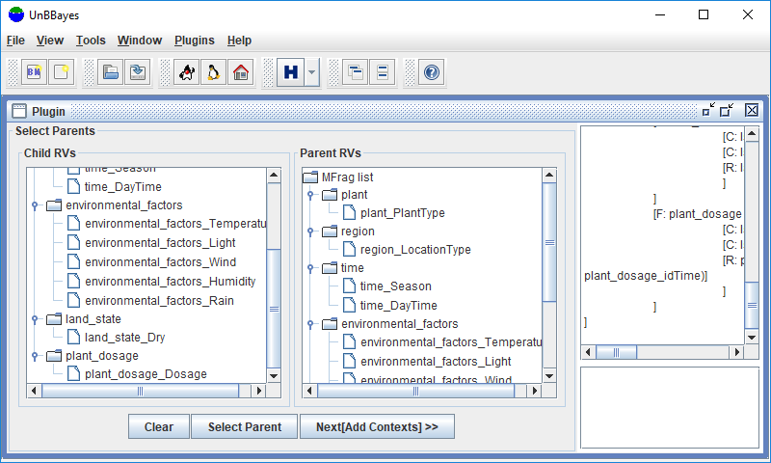

Click the button “Next[Add Contexts]>>”.

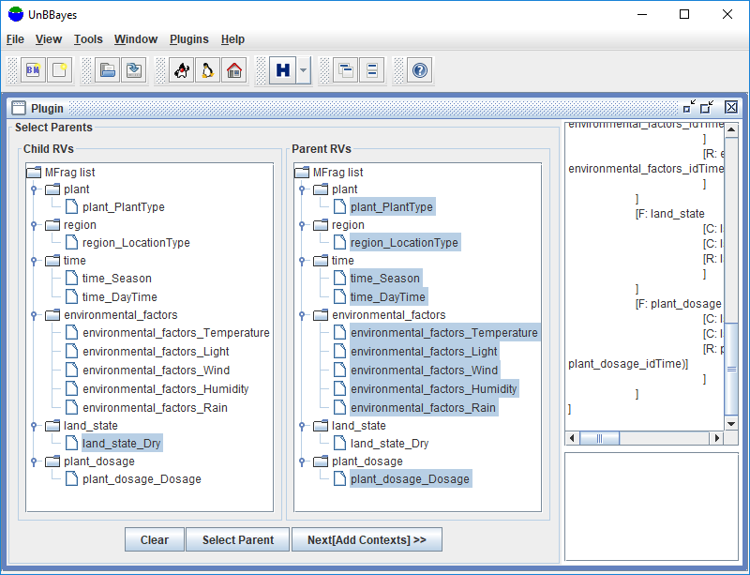

Click the button “Next[CLDs]>>”.

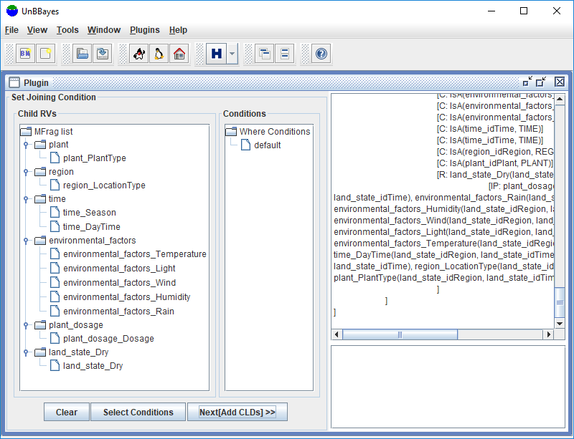

Click the button “Next[MEBN Learning]>>”.

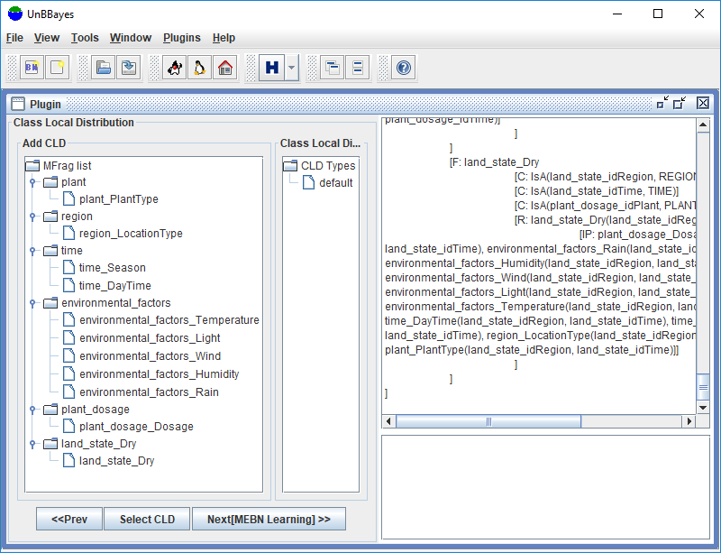

Then we can see a learned MTheory.

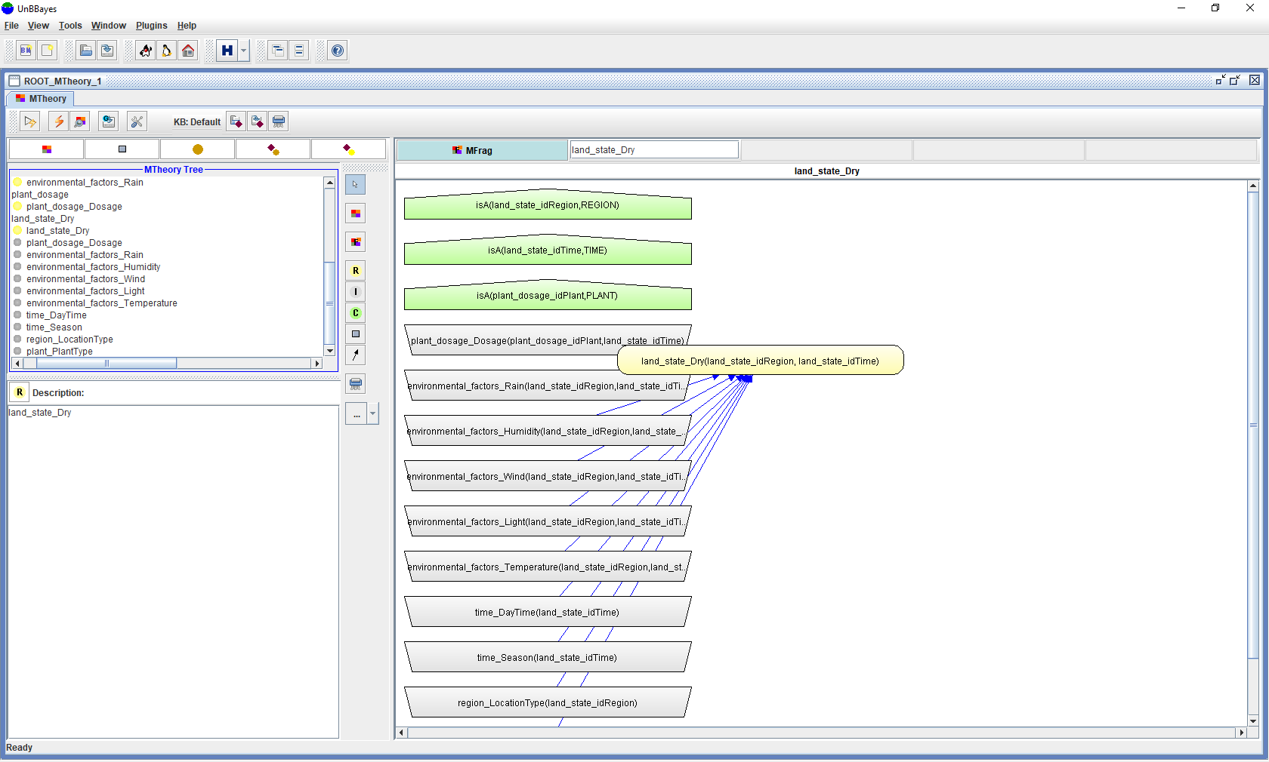

## Reasoning the WateringSystem MTheory

To reason about the node “land_state_Dry”, we need to set knowledge base (KB).

We can find a sample KB in the following folder.

example_data/watering_system/test.plm

Click the button “Load Knowledge Base” and load the file “test.plm”.

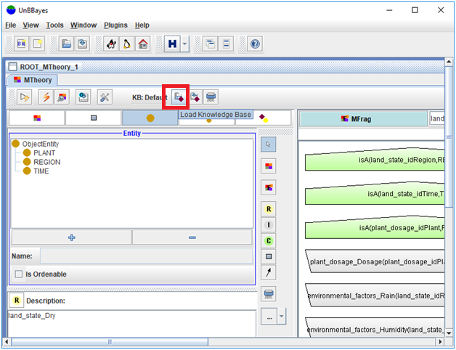

To query the node “land_state_Dry”, click the button “Execute Query”.

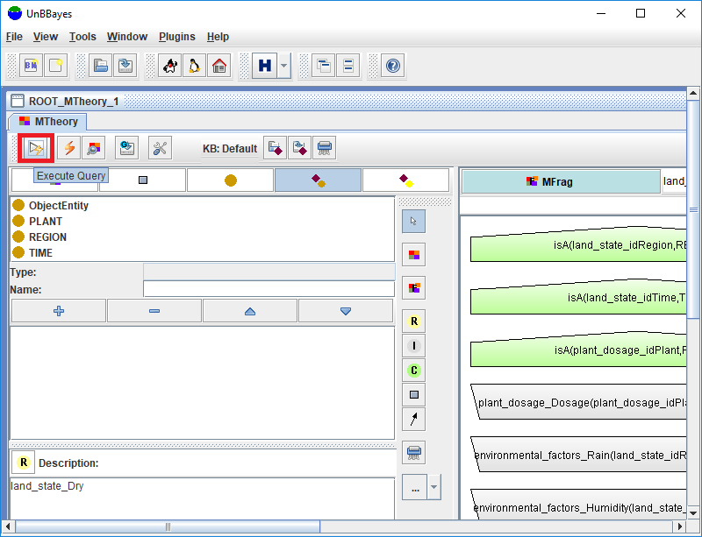

Select the item “land_state_Dry”.

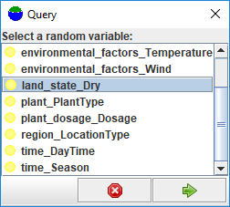

Select the entity instant R1 for REGION_label and the entity instance T1 for the TIME_label.

Then click the button “Query”.

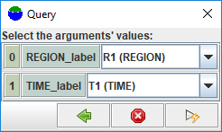

Then, we can see a reasoned SSBN from the WateringSystem MTheory.

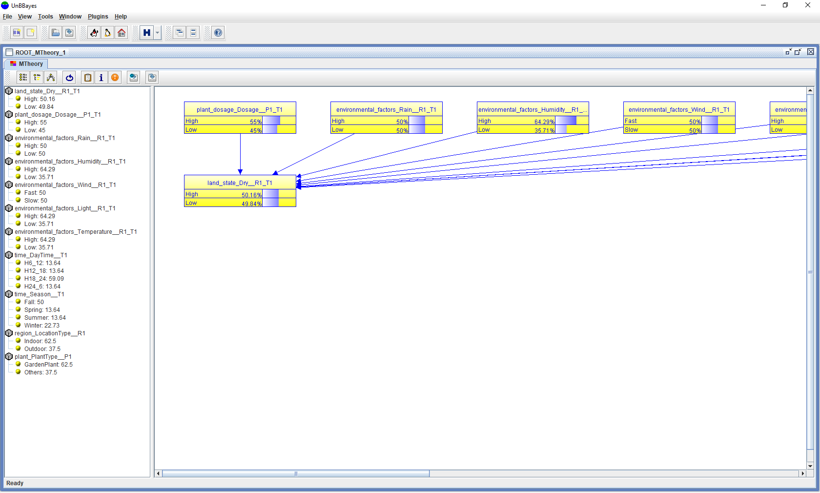

## [References]

1. [arXiv] Park, C. Y., Laskey, K. B., Costa, P. C., & Matsumoto, S. (2018a). Gaussian Mixture Reduction for Time-Constrained Approximate Inference in Hybrid Bayesian Networks. <https://arxiv.org/abs/1806.02415>
2. [arXiv] Park, C. Y. & Laskey, K. B. (2018b). Human-aided Multi-Entity Bayesian Networks Learning from Relational Data. <https://arxiv.org/abs/1806.02421>
3. [arXiv] Park, C. Y. & Laskey, K. B. (2018c). MEBN-RM: A Mapping between Multi-Entity Bayesian Network and Relational Model. <https://arxiv.org/abs/1806.02455>
4. [arXiv] Park, C. Y. & Laskey, K. B. (2018d). Reference Model of Multi-Entity Bayesian Networks for Predictive Situation Awareness. <https://arxiv.org/abs/1806.02457>
5. Park, C. Y., Laskey, K. B., Costa, P. C., & Matsumoto, S. (2016c). A Process for Human-aided Multi-Entity Bayesian Networks Learning in Predictive Situation Awareness. In Information Fusion (FUSION).
6. Park, C. Y., Laskey, K. B., Costa, P. C., & Matsumoto, S. (2014, July). Predictive situation awareness reference model using multi-entity Bayesian networks. In Information Fusion (FUSION), 2014 17th International Conference on (pp. 1-8). IEEE.
7. Park, C. Y., Laskey, K. B., Costa, P. C. G., & Matsumoto, S. (2013b). Multi-Entity Bayesian Networks Learning For Hybrid Variables In Situation Awareness. Proceedings of the 16th International Conference on Information Fusion (Fusion 2013).
8. Park, C. Y., Laskey, K. B., Costa, P. C. G., & Matsumoto, S. (2013a). Multi-Entity Bayesian Networks Learning In Predictive Situation Awareness. Proceedings of the 18th International Command and Control Technology and Research Symposium (ICCRTS 2013).